Bridgepoint Parts Catalog

Section XXXIX: Brush Pro Parts Page 1

NM5218 E27

Handle Connector Part G

Lower Part - All Brush Pros

NM5200 E1

Snap Ring A12

Brush Pro 17& 10

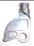

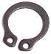
Now sold with
NM5242

NM5202 E2 / G2

Ball Bearing 6002-2RS

Brush Pro 17& 10

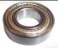

NM5219 E29 / G29

Handle Connector Part E

Lower Part - All Brush Pros

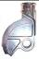

NM5220 E31 / G31

Gear 48 Right

Brush Pro 17 & 10

NM5204 E8 / G8

Trolley Brush Pro 17

Complete Assembly

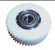
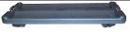

NM5222 E32 G32

Gear 48 Left

Brush Pro 17& 10

NM5206 E13 / G13

Microswitch with Lever

Brush Pro 17

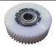
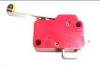

NM5224 E35

Gear 66 Right

Brush Pro 17& 10

NM5208 E14 / G14

Switch Part

Brush Pro 17& 10

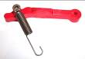

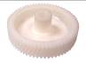

NM5210 E19 / G19

Ball Bearing 6003-2RS

Brush Pro 17& 10

NM5226 E39 / G39

Thermo-relay

Brush Pro 17

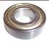

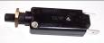

NM5228 E40

Gear 66 Left

Brush Pro 17& 10

NM5212 E20 / G20

Flange – ALL Brush Pros

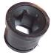

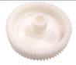

NM5334 S86

Conductor Board

Brush Pro 20

NM5214 E22 / G22

Retaining Ring

All Brush Pros

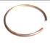
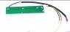

NM5336 S88

Power Inlet Module
Brush Pro 20

NM5216 E26 / G26

Brush Axle – Brush Pro 17

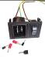

Bridgepoint Parts Catalog

Section XXXIX: Brush Pro Parts Page 2

NM5250 S2

Side Plate

Brush Pro 20

NM5230 G41

Gear 85 Right

Brush Pro 17LM & 20LM

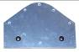
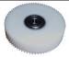

NM5252 S3

Cover – Brush Pro 20

w/ switches, conductor board

& power inlet module
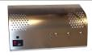

NM5232 E42 / G42

Ball Bearing 6000

Brush Pro 17

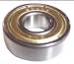

NM5254 S4

Renovator Mounting Sheets

Brush Pro 20

NM5234 E45 / G45

Grommet

Brush Pro 17&10

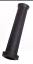
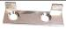

NM5256 S5

Gear Cover

Brush Pro 20

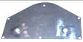

NM5236 E46 / G46

Power Cord

Brush Pro 10, 17, LM17 & LM20

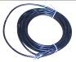

NM5260 S10

Bearing – Brush Shaft w/ set screw & lock ring

Brush Pro 20

NM5238 E50 / G50

Capacitor

Brush Pro 17& 10

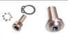
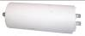

NM5262 S11

Handle Axle – Right w/ screw

Brush Pro 20

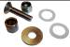

NM5240 E66 / G66

Cable Protector

Brush Pro 17

NM5264 S12

Handle Holder w/ Camshaft Brush Pro 20

NM5242

E68/27 / G68/27

Handle Stop & Connector Part G

All Brush Pros

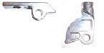

NM5244 E69 / G69

Spring – Handle Stop

All Brush Pros

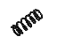

NM5246 E126 / G126

Cord Holder - Right

Brush Pro 17&10

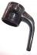

NM5248 S1

Gear Plate – w/ Brush Gears

Brush Pro 20

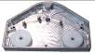

Bridgepoint Parts Catalog

Section XXXIX: Brush Pro Parts Page 3

NM5284 S25

Microswitch w/ screws

Brush Pro 20

NM5266 S13

Brush Cover

Brush Pro 20

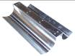
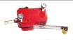

NM5286 S27

Tension Rod 27”

Brush Pro 20

NM5268 S14

Bushing Handle Axle - Right Brush Pro 20
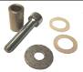

NM5288 S28

Accelerator Rod w/ screws

Brush Pro 20

NM5270 S15

Tension Rod 15”

Brush Pro 20

NM5272 S16

Brush Axle

Brush Pro 20

NM5290 S29

Screw for Cable Protector

Brush Pro 20

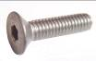

NM5274 S17

Handle Mount Cone w/ screw Brush Pro 17 & 20

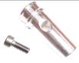

NM5292 S30

Motor w/ fan & bearing

Brush Pro 20

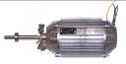

NM5258 S7

Motor Shaft Case

Brush Pro 20

NM5276 S18

Cable Protector

Brush Pro 20

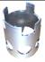
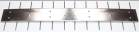

NM5294 S35

Screw for Bearing Shaft

Brush Pro 20

NM5278 S19

Handle Stop

Brush Pro 20

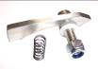
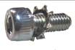

NM5296 S38

Screw for Bearing Cover

Brush Pro 20

NM5280 S20

Flange Bearing Nut w/ring

Brush Pro 20

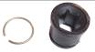
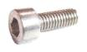

NM5282 S21

Bearing Cover

Brush Pro 20

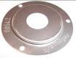

Bridgepoint Parts Catalog

Section XXXIX: Brush Pro Parts Page 4

NM5298 S43.1

Screw for Covers

Brush Pro 20

NM5318 S62

Ventilator – Motor Fan

Brush Pro 20

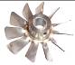
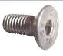

NM5300 S43.2

Screw for Renovator MS

Brush Pro 20

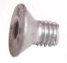

NM5320 S66

Washer - Polymid

Brush Pro 20

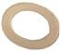

NM5302 S44

Screw for Tension Rods

Brush Pro 20

NM5322 S67

Frequency Converter w/ Mount

Brush Pro 20

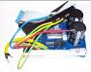

NM5304 S50

Gear 62 Left w/ bearing

Brush Pro 20

NM5324 S71

Sealing Strip

Brush Pro 20

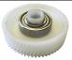

NM5306 S51

Gear 57 w/ bearing

Brush Pro 20

NM5326 S76

Power Cord

Brush Pro 20

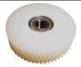
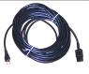

NM5308 S52

Gear 42 w/ bearing

Brush Pro 20

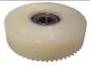

NM5328 S79.1

Gear Plate Mount

Brush Pro 20

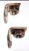

NM5330 S79.2

Side Plate Mount

Brush Pro 20

NM5310 S53

Gear 83 w/ bearing

Brush Pro 20

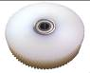

NM5312 S54

Gear 62 Right w/ bearing

Brush Pro 20

NM5332 E88 / S80

Handle - Complete

Brush Pro 17 & 20

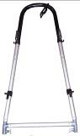
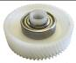

NM5314 S57

Bearing Motor Shaft w/ Ring

Brush Pro 20

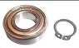

NM5354 ZZZ111

Accessory Holder
Brush Pro 20

NM5316 S59

Snap Ring - Gear 62

Brush Pro 20

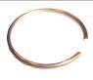
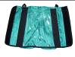

Bridgepoint Parts Catalog

Section XXXIX: Brush Pro Parts Page 5

NM5201 G3

Distance Piece G
Brush Pro 17LM

NM5203 G4

Split Pin

NM5204A X35D

Transport Trolley – Complete
Brush Pro 17LM

NM5205 G5

Ventilator

NM5209 G7

Distance Piece C
Brush Pro 17LM

NM5211 G9

Extension Spring

NM5213 G10

Worm Screw
M3 x 40

NM5207 G6

Motor – Brush Pro 17LM

NM5229 G21

Housing Unit G - Complete

NM5227 G18

Screw - Housing Unit
M5 x 12

NM5225 G17

Washer M5

NM5215 G11

Nut M3

NM5217 G12

Spring Ring M3

NM5231 G23

Protective Plate
Bearing Cover

NM5221 G15

Worm Screw M5 x 25

NM5223 G16

Nut M5

NM5233 G24

Motor Stud – Brush Pro 17LM

NM5235 G25

Brush Cover – Interior
Brush Pro 17LM

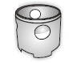
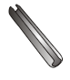
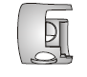
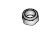
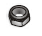
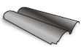
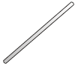

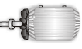



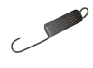
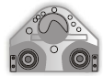

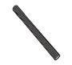
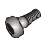




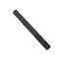

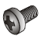
Bridgepoint Parts Catalog

Section XXXIX: Brush Pro Parts Page 6

NM5237 G28

Protective Plate
Bearing Cover

NM5239 G30

Screw M6 x 16

NM5255 G52

Cylinder Head Screw
M5 x 12

NM5257 G53

Starting Control Unit

NM5241 G33

Gear Cover

NM5243 G34

Lock Washer

NM5245 G36

Housing Unit G – Complete

NM5259 G54

Clamp Strap

NM5261 G55

Trolley Clip w/ Rivets

NM5263 G56

Cable Clamp

NM5265 G57

Cylinder Head Screw
M3 x 25

NM5247 G37

Motor Cover
Brush Pro 17LM

NM5249 G47

Bearing Pin

NM5267 G58

Wire Fixing Plate

NM5251 G49

Cylinder Hear Screw
M4 x 8

NM5253 G51

Start Capacitor 80µf

NM5269 G60

Terminal EKL 1

NM5271 G61

V-Ring


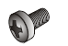
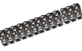

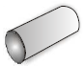
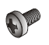

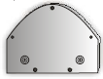
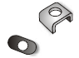

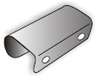

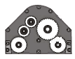
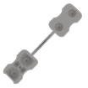

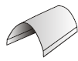

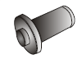
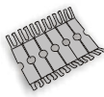

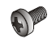

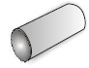


Bridgepoint Parts Catalog

Section XXXIX: Brush Pro Parts Page 7

NM5273 G62

Worm Screw

NM5275 G63

Nut M4

NM5291 G76

Washer Disc

NM5293 G77

Screw for Protector Plate
M3 x 5

NM5277 G64

Lock Washer

NM5279 G67

Blind

NM5281 G70

Plastic Strip Formed

NM5295 G78

Snap In – Handle Connect

NM5297 G79

Handle – Upper Section

NM5299 G80

Bearing

NM5301 G83

Cross Bar
Brush Pro 17LM

NM5283 G71

Snap Ring A15

NM5285 G72

Switch Cover

NM5303 G84

T-Piece Left Coupler

NM5287 G74

Handle Connector - Upper

NM5289 G75

Flat Bar
Brush Pro 17LM

NM5305 G86-35

Tandem Bar
Brush Pro 17LM

NM5307 G88

Handle – Complete Assembly
Brush Pro 17LM

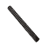




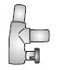

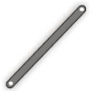

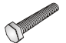

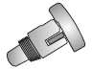

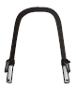

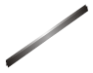

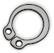

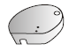

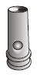

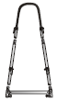

Bridgepoint Parts Catalog

Section XXXIX: Brush Pro Parts Page 8

NM5309 G95

Spring Ring M5

NM5311 G96

Cylinder Head Screw
M6 x 30

NM5327 G124

T-Piece Right Coupler

NM5329 G127

Countersunk Head Screw
M5 x 6

NM5313 G109

Isolation Plate

NM5315 G113

Cylinder Head Screw
M6 x 16

NM5317 G116

Spring Ring

NM5331 G128

Holder - Left

NM5333 G129

Holder - Right

NM5335 G130

Throw-In Accelerator
Brush Pro 17LM

NM5337 G131

Countersunk Head Screw
M4 x 12

NM5319 G118

Snap Ring A10

NM5321 G120

Screw M6 x 16

NM5339 G132

Protective Cover

NM5323 G122

Handle Lower Section Left

NM5325 G123

Handle Lower Section Right

NM5341 G133

Countersunk Head Screw
M4 x 8

NM5343 G134

O-Ring


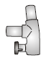
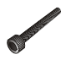

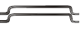

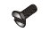


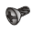

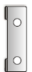

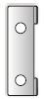

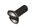


Bridgepoint Parts Catalog

Section XXXIX: Brush Pro Parts Page 9

NM5345 G135

Hex Bar Cable Protector
Brush Pro 17LM

NM5347 G136

Wheel for Brush Cover

NM5363 X35B

Renovator Kit - 2PC
Brush Pro 17LM

NM5365 X35C

Dustcover – without Wheels

Brush Pro 17LM

NM5349 G149

Pig Tail Cable

NM5351 G152

Front Upright – Trolley
Brush Pro 17LM

NM5353 G153

Large Wheel - Trolley

NM5367 X35E

Dustcover – with Wheels
Brush Pro 17LM

NM5369 X35D

Transport Trolley – Complete
Brush Pro 17LM

NM5371 G3-45

Distance Piece G
Brush Pro 20LM

NM5373 G6-45

Motor – Brush Pro 20

NM5355 G154

Axle Trolley
Brush Pro 17LM

NM5357 G155

Fixing Belt - Trolley

NM5374 G7-45

Distance Piece E
Brush Pro 20LM

NM5359 G156

Tray with Clips – Trolley
Brush Pro 17LM

NM5361 G157

Fixation Buckle - Complete

NM5375 G24-45

Motor Stud
Brush Pro 20LM

NM5376 G25-45

Brush Cover – Interior
Brush Pro 20LM

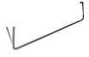


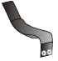



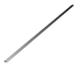

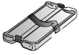

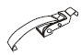

Bridgepoint Parts Catalog

Section XXXIX: Brush Pro Parts Page 10

NM5377 G26-45

Brush Axle
Brush Pro 20LM

NM5378 G37-45

Motor Cover
Brush Pro 20LM

NM5397 G135-45

Hex Bar Cable Protector
Brush Pro 20LM

NM5398 G152-45

Front Upright – Trolley
Brush Pro 20LM

NM5379 G66-45

Cable Protector
Brush Pro 20LM

NM5381 G70-45

Plastic Strip – Formed
Brush Pro 20LM

NM5386 G75-45

Flat Bar
Brush Pro 20LM

NM5399 G154-45

Axle Trolley
Brush Pro 20LM

NM5401 G156-45

Tray with Clips – Trolley
Brush Pro 20LM

NM5409 X45B

Renovator Kit – 2 PC
Brush Pro 20LM

NM5411 X45C

Dust Cover without wheels
Brush Pro 20LM

NM5387 G83-45

Cross Bar
Brush Pro 20LM

NM5388 G86-45

Tandem Bar
Brush Pro 20LM

NM5413 X45E

Dust Cover with Wheels
Brush Pro 20LM

NM5389 G88-45

Handle – Complete
Brush Pro 20LM

NM5396 G130-45

Throw-In Accelerator
Brush Pro 20LM

NM5415 X45D

Transport Trolley – Complete
Brush Pro 20LM

MH52C

Brush 20” Brush Pro 20

For Commercial Carpet

Set of Two Brushes

18” X 4-1/2”

Bridgepoint Parts Catalog

Section XXXIX: Brush Pro Parts Page 11

MH51B

Brush 17” Brush Pro 17

Standard

Set of Two Brushes

15-1/2” X 4-1/2”

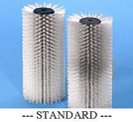

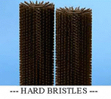

WHITE

MH51W

Brush 17” Brush Pro 17

For Wool Rugs 15-1/2” X 4-1/2”

Set of Two Brushes

MH52B

Brush 20” Brush Pro 20

Standard Set of Two Brushes

18” X 4-1/2”

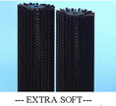
OLD - BLACK

NEW - OFF WHITE

MH51C

Brush 17” Brush Pro 17

For Commercial Carpet

Set of Two Brushes 15-1/2” X 4-1/2”

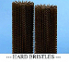

MH54C

Brush 20” Brush Pro 20LM

SOFT WHITE

Set of Two Brushes

18” X 4-1/2”

OLD - BROWN

NEW - BLACK

MH53E

Brush 16” Brush Pro 17LM

EXTRA AGGRESSIVE BLACK

Set of Two Brushes

14” X 4-1/2”

MH54B

Brush 20” Brush Pro 20LM

STANDARD BLUE

Set of Two Brushes

18” X 4-1/2”

MH53D

Brush 16” Brush Pro 17LM

AGGRESSIVE BROWN

Set of Two Brushes

14” X 4-1/2”

MH54D

Brush 20” Brush Pro 20LM

AGGRESSIVE BROWN

Set of Two Brushes

18” X 4-1/2”

MH53B

Brush 16” Brush Pro 17LM

STANDARD BLUE

Set of Two Brushes

14” X 4-1/2”

MH54E

Brush 20” Brush Pro 20LM

EXTRA AGGRESSIVE BLACK

Set of Two Brushes

18” X 4-1/2”

MH10A

White – Medium Brush

Brush Pro 10

Set of Two Brushes

MH53C

Brush 16” Brush Pro 17LM

SOFT WHITE

Set of Two Brushes

14” X 4-1/2”

MH10B

Black– Soft Brush

Brush Pro 10

Set of Two Brushes

MH10C

Brown – Stiff Brush

Brush Pro 10

Set of Two Brushes

Bridgepoint Parts Catalog

Section XXXIX: Brush Pro Parts Page 12

NM5350 X48

Dirt Receptacles Set of Two

Brush Pro 20 – Old Style
Front & Back

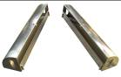

NM5352 XPROC

Brush Covers – Set of Two

Brush Pro 20 – Old Style
Front & Back

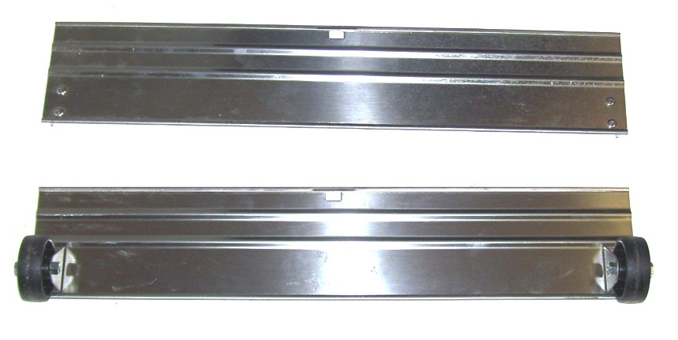

NM5338 S89

Fuse Holder w/ Fuse

Brush Pro 20 – old style

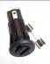

NM5340 SX20

Caster – w/ screws

Trolley - Brush Pro 20

Old Style

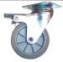

NM5342 SX30

Wheel

Trolley - Brush Pro 20 old style

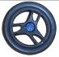

NM5344 SX50

Strap w/ Plate & Rivets

Trolley - Brush Pro 20

OLD STYLE

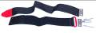

NM5346 SX60

Trolley – Complete

Brush Pro 20 Old Style

